Yiğit Bozkurt- 214990826

CS 240 Final Project

Part 1

1. Is there any relations teams’ home won and teams’ away won?

2. Are the players' allstar values close to the year average?

3. how effective the teams are to winning

I choose the first one.

Part 2

I use this columns in this pictures.

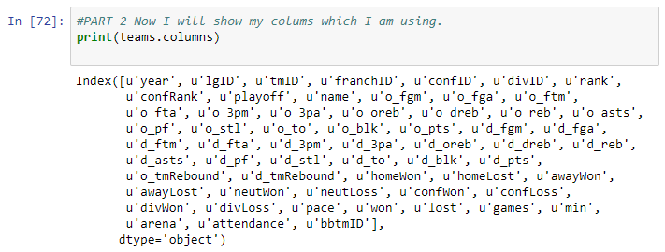

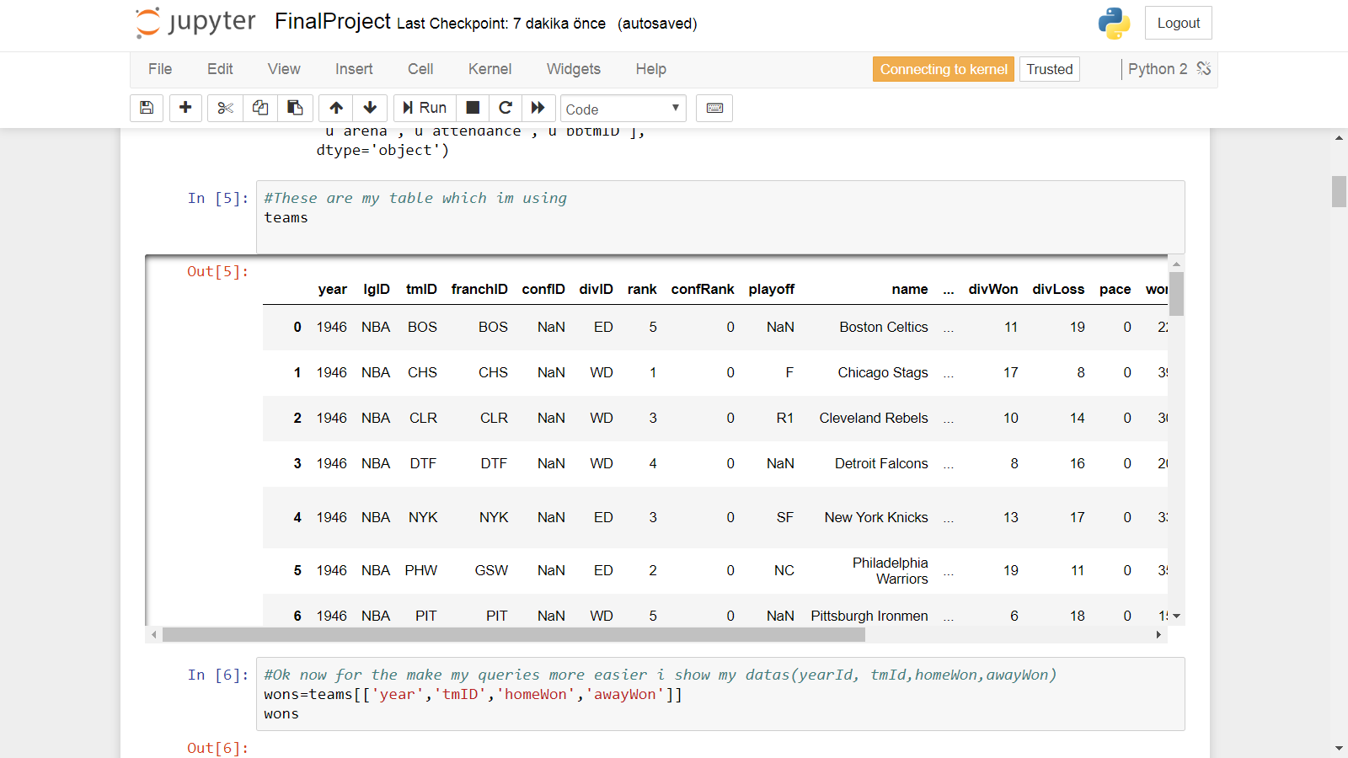

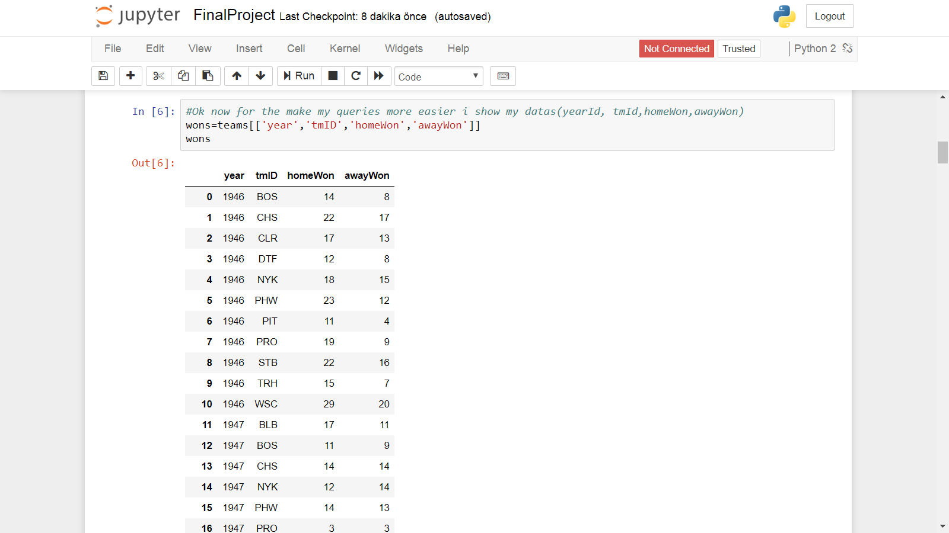

Part 3

I count some descriptions which are mean, variance, pmf, cdf etc. 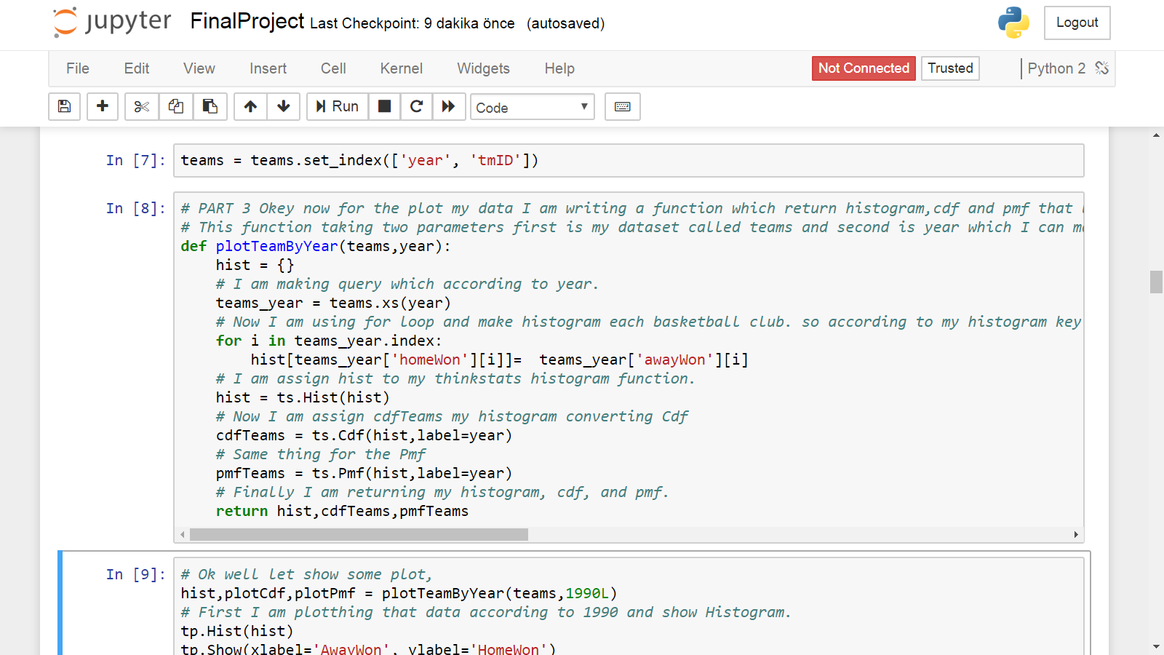

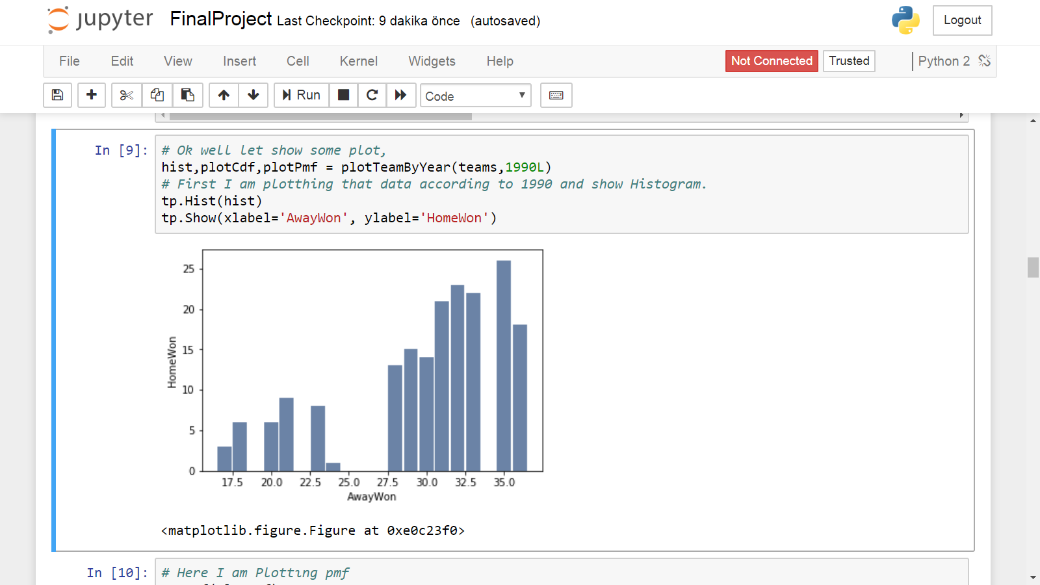

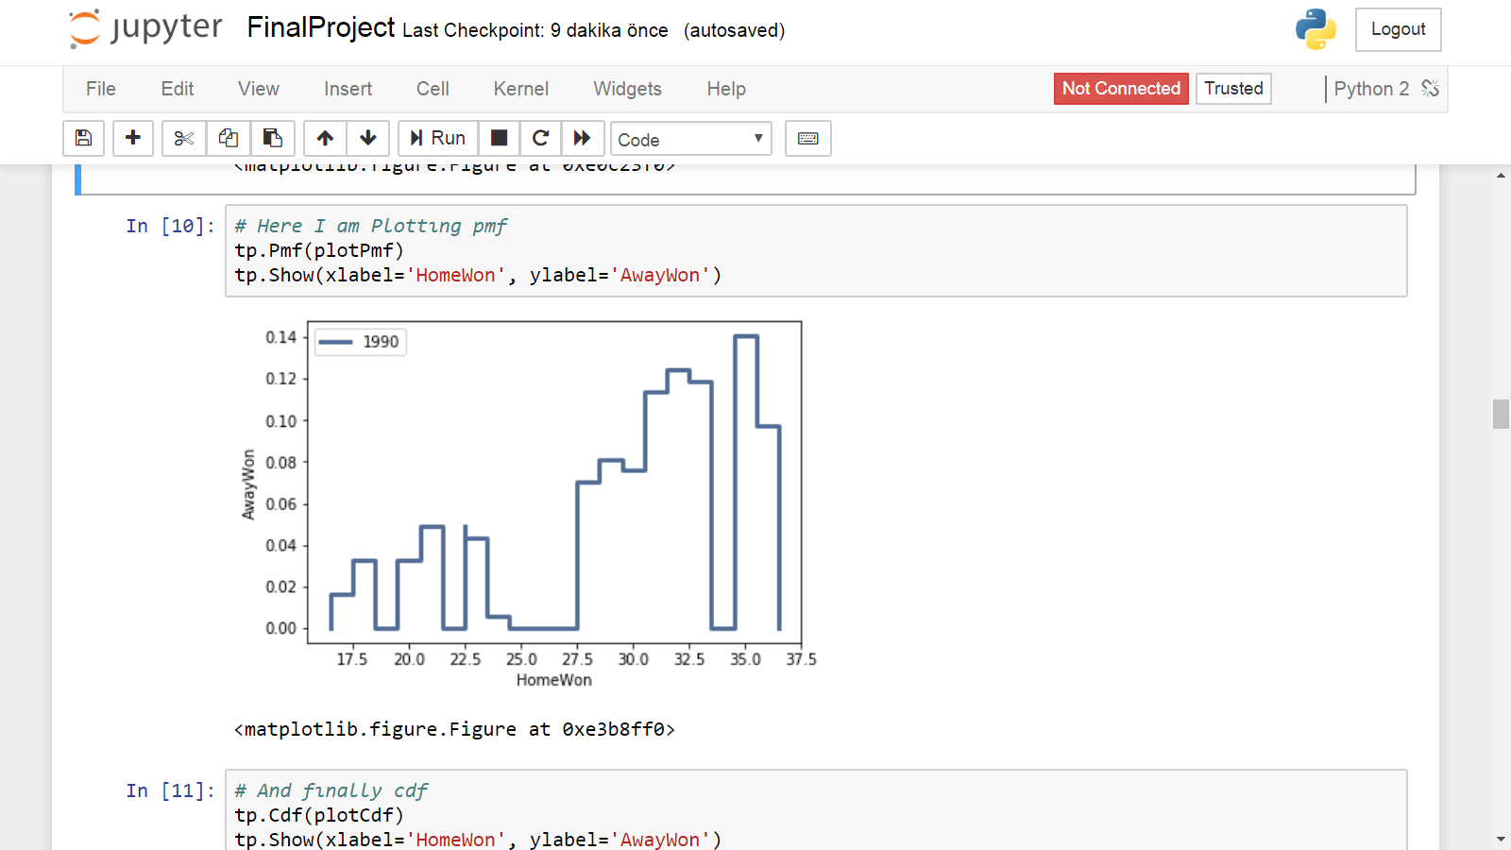

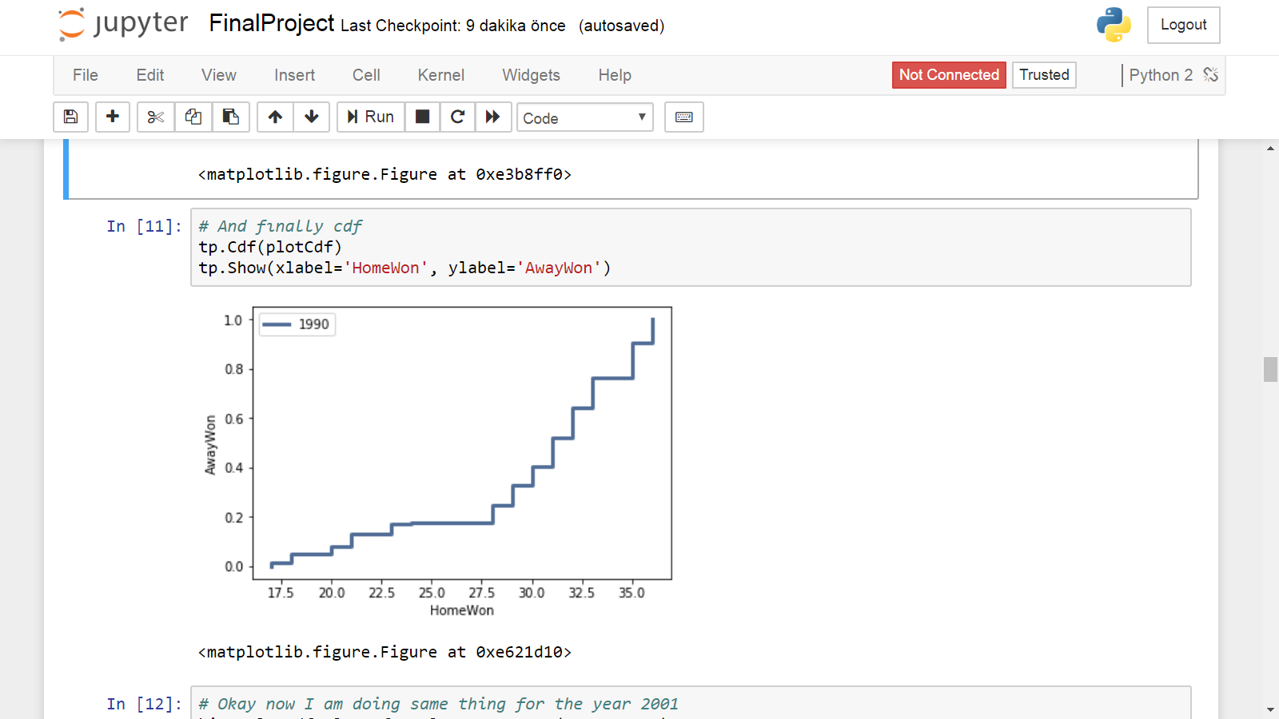

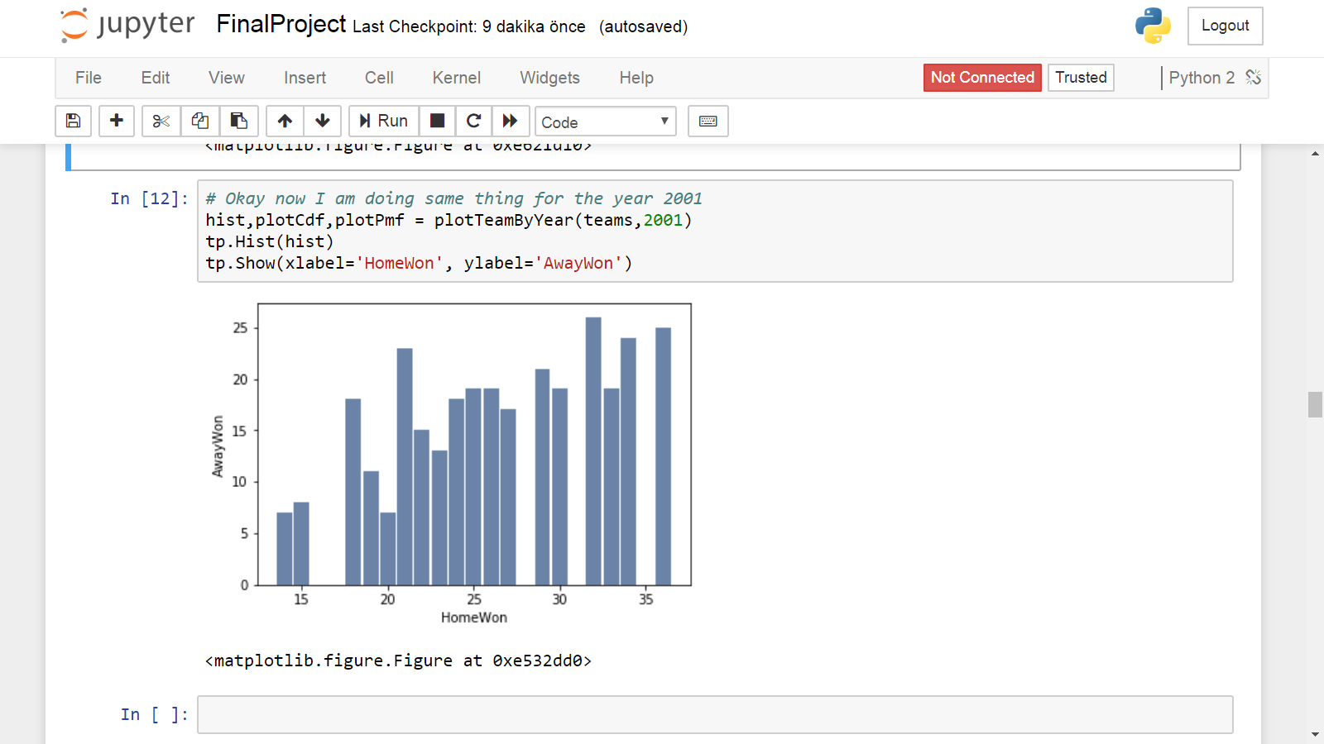

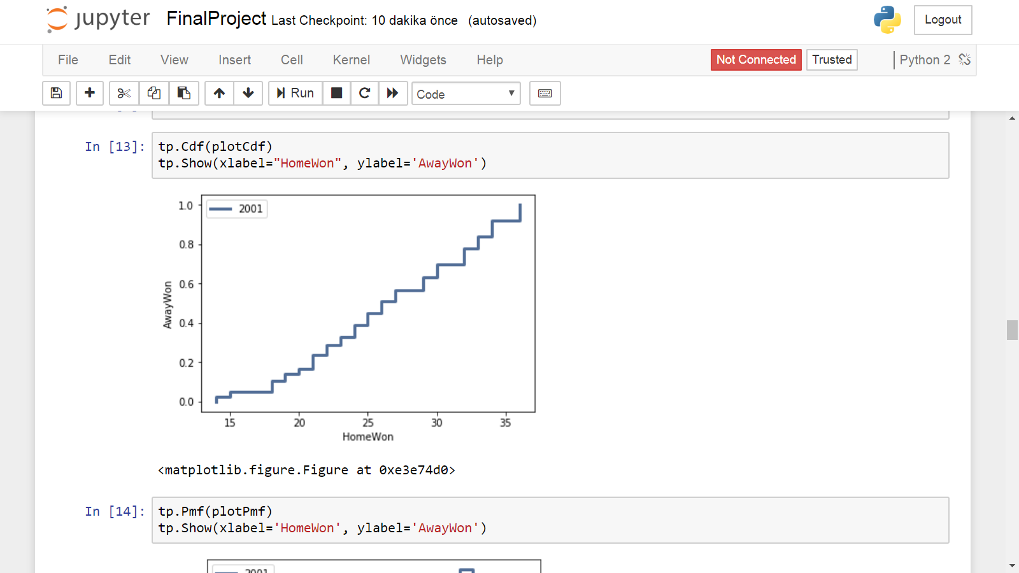

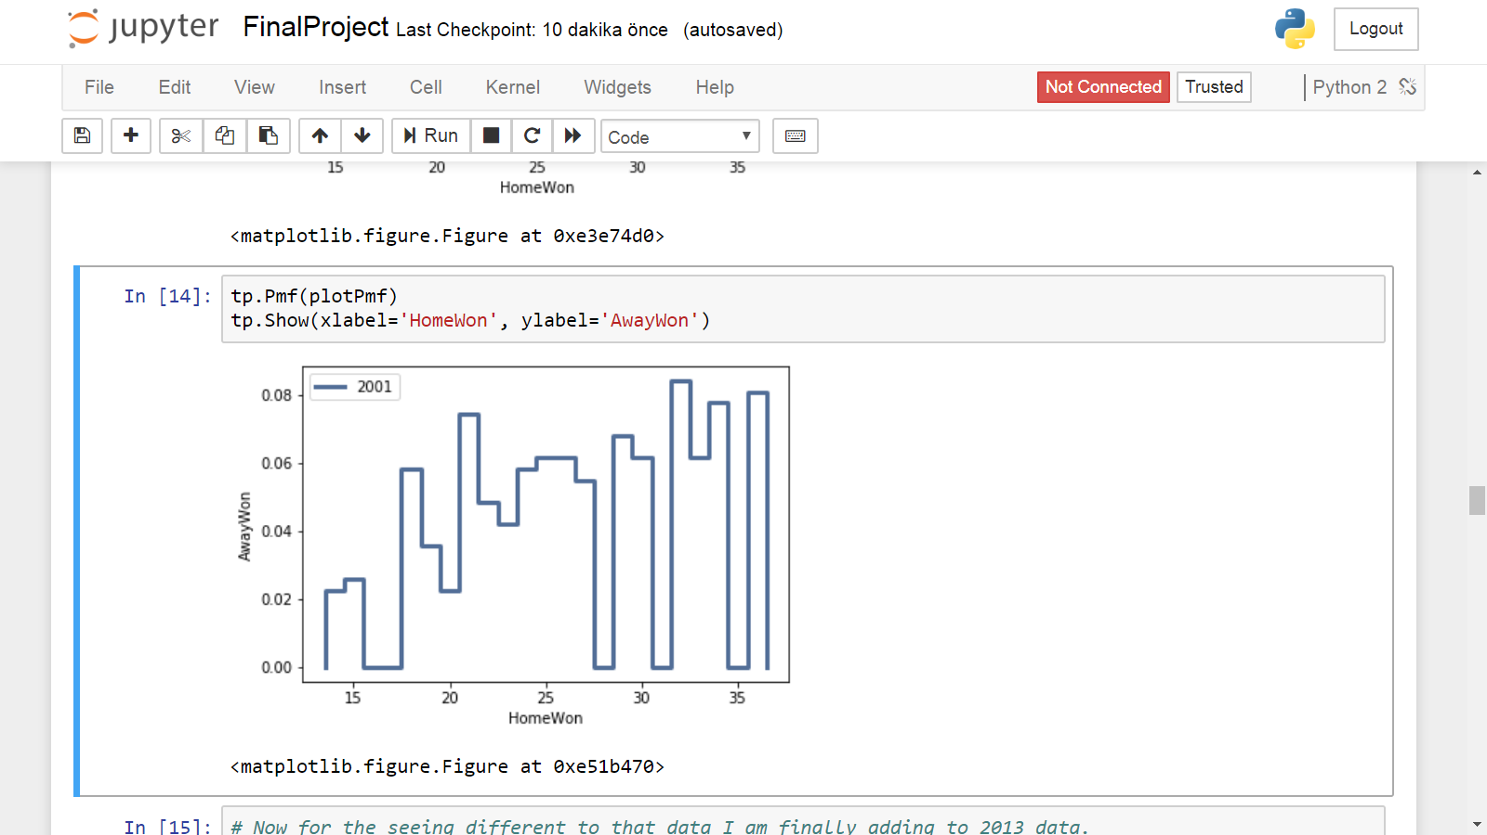

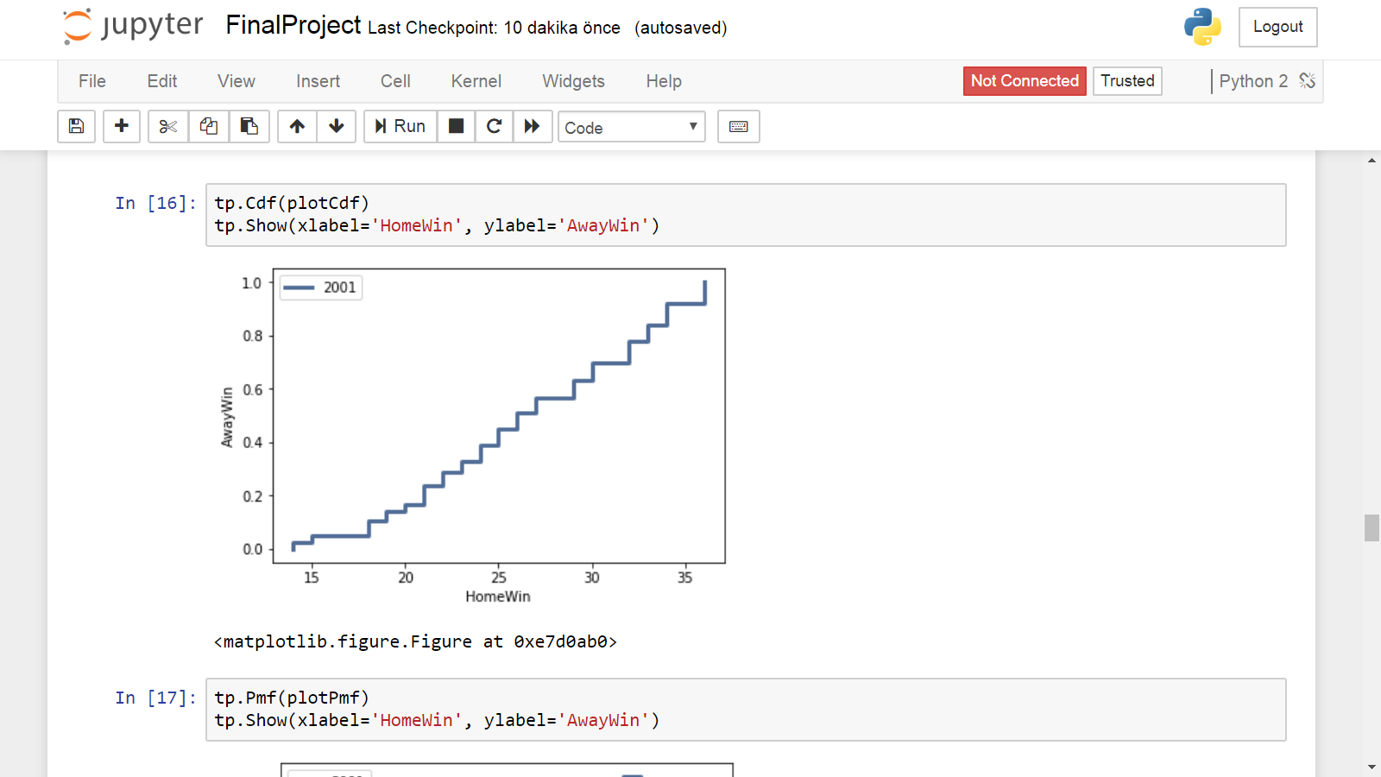

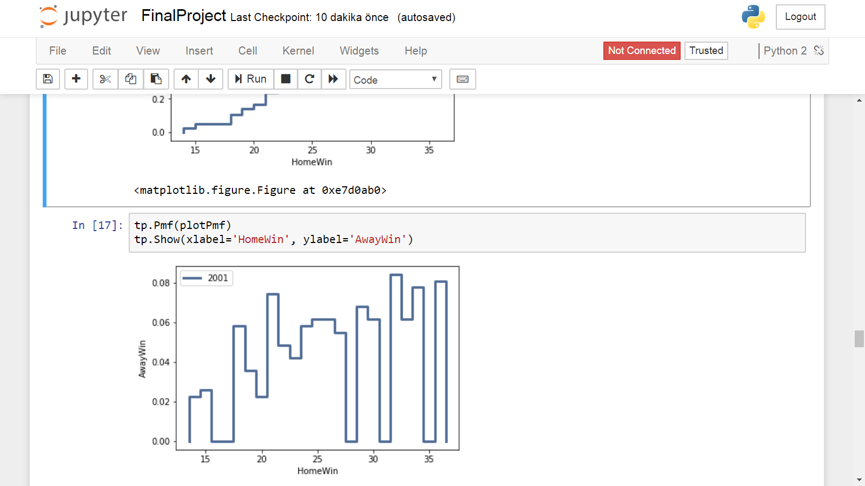

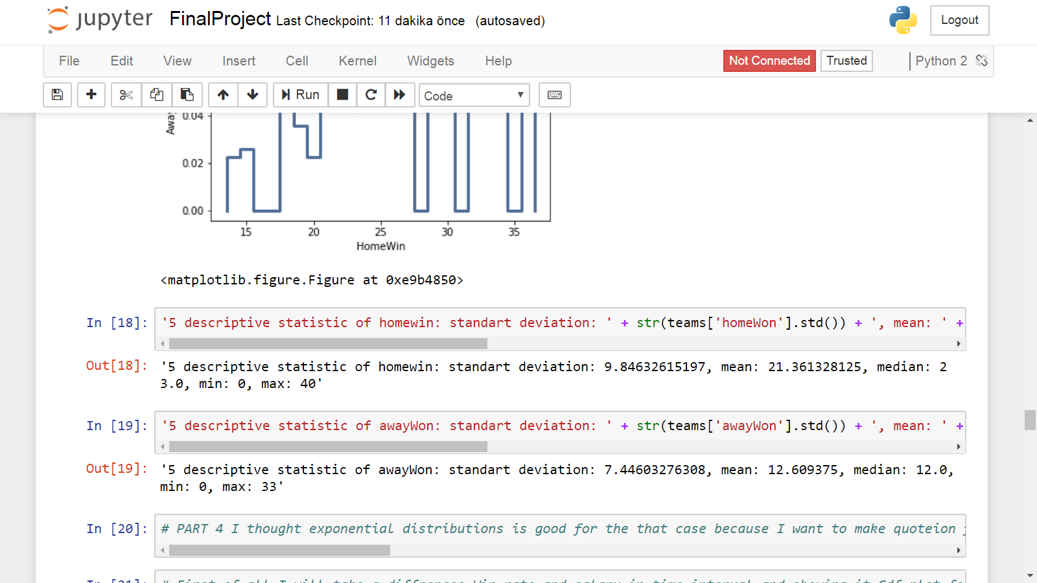

In short, I thing this part most important because I am showing important dataset which as virtualized.

Part 4

I thought exponential distributions is good for the that case because I want to make quoteion from books. "In the real world, exponential distributions come up when we look at a series of events and measure the times between events, called interarrival times." so for the observing events(homewon rate) and awaywon change in the year is the best distrubiton.

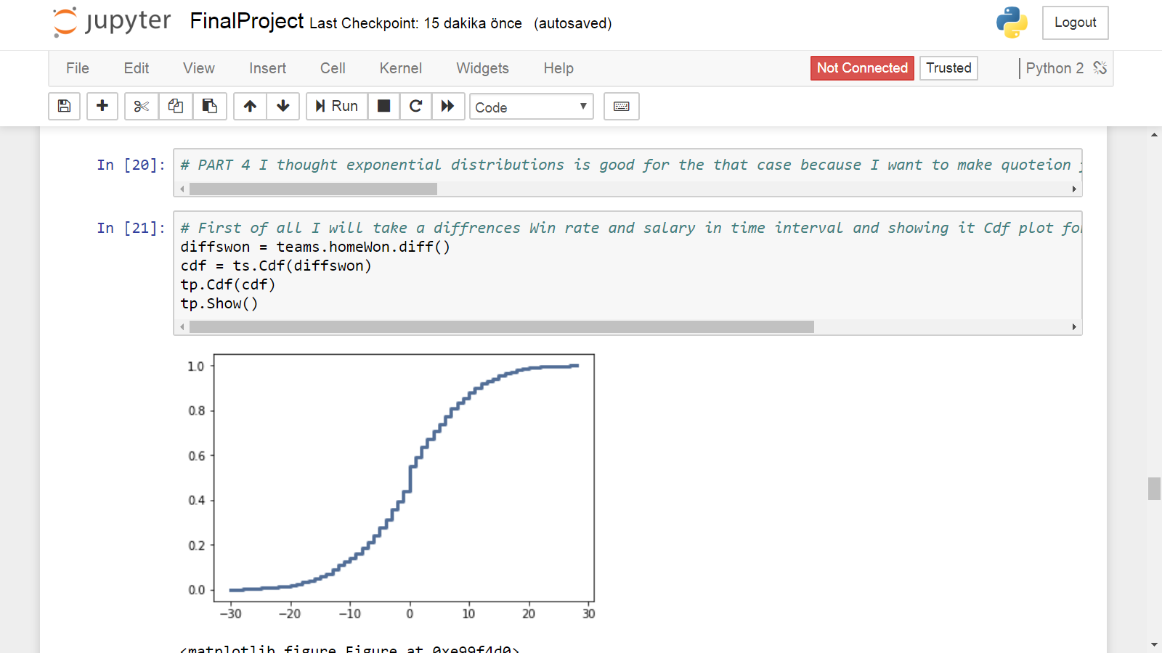

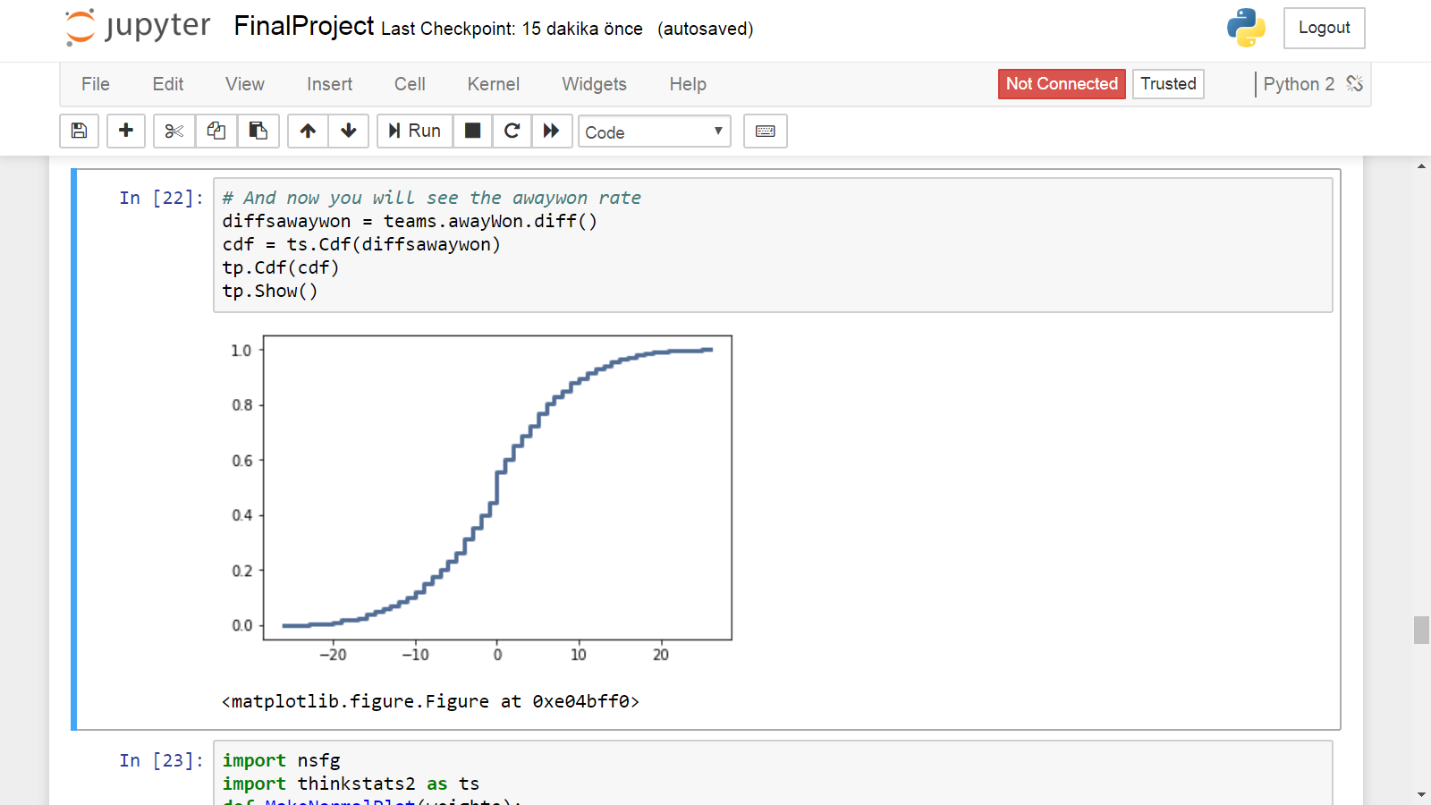

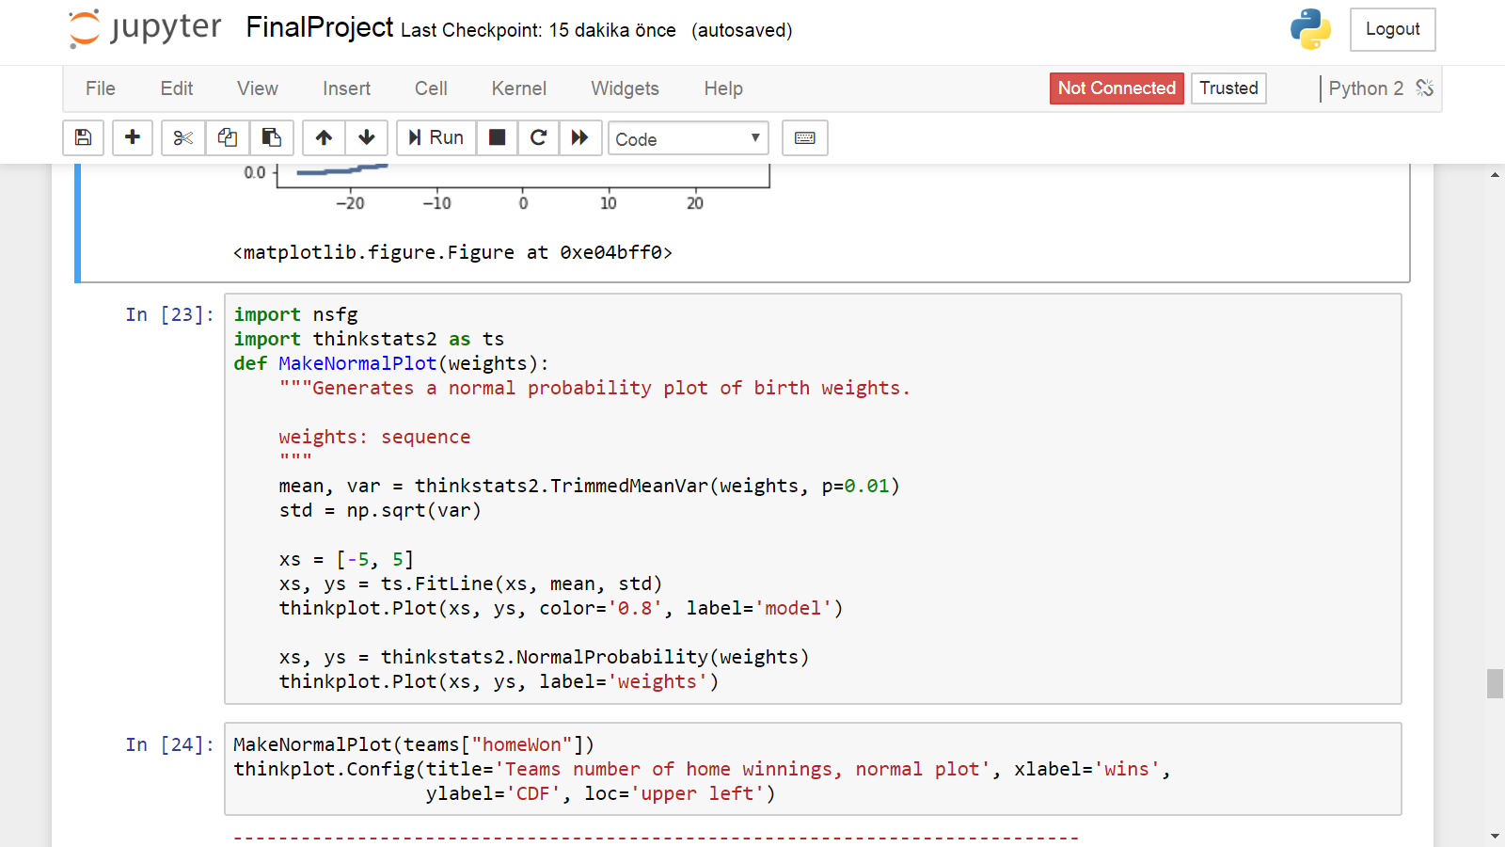

Part 5

So for that part I guess I did this part in part two because I did built one relationship in totalhomewon-Total awaywon and showed in one plotting.

But I did some thing different from part two.

I calculate these’ covariance.

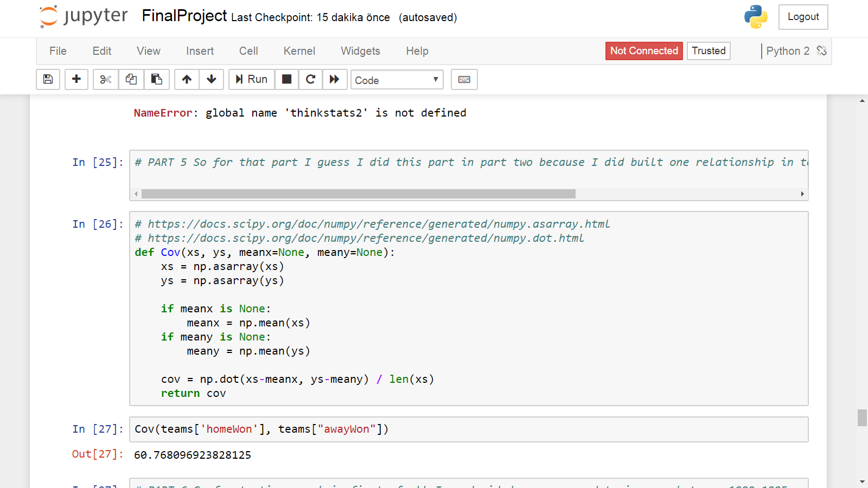

Part 6

So for testing my claim first of all I am decided compare my data in year between 1990,1995 and 2000 So in Pmf I can show my hpothesis

So first of all I am used my previous my function named plotTeamByYear

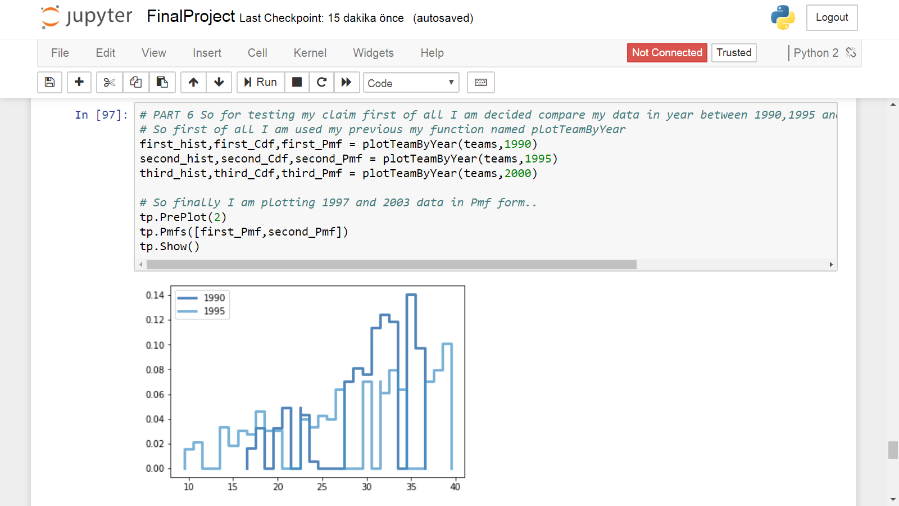

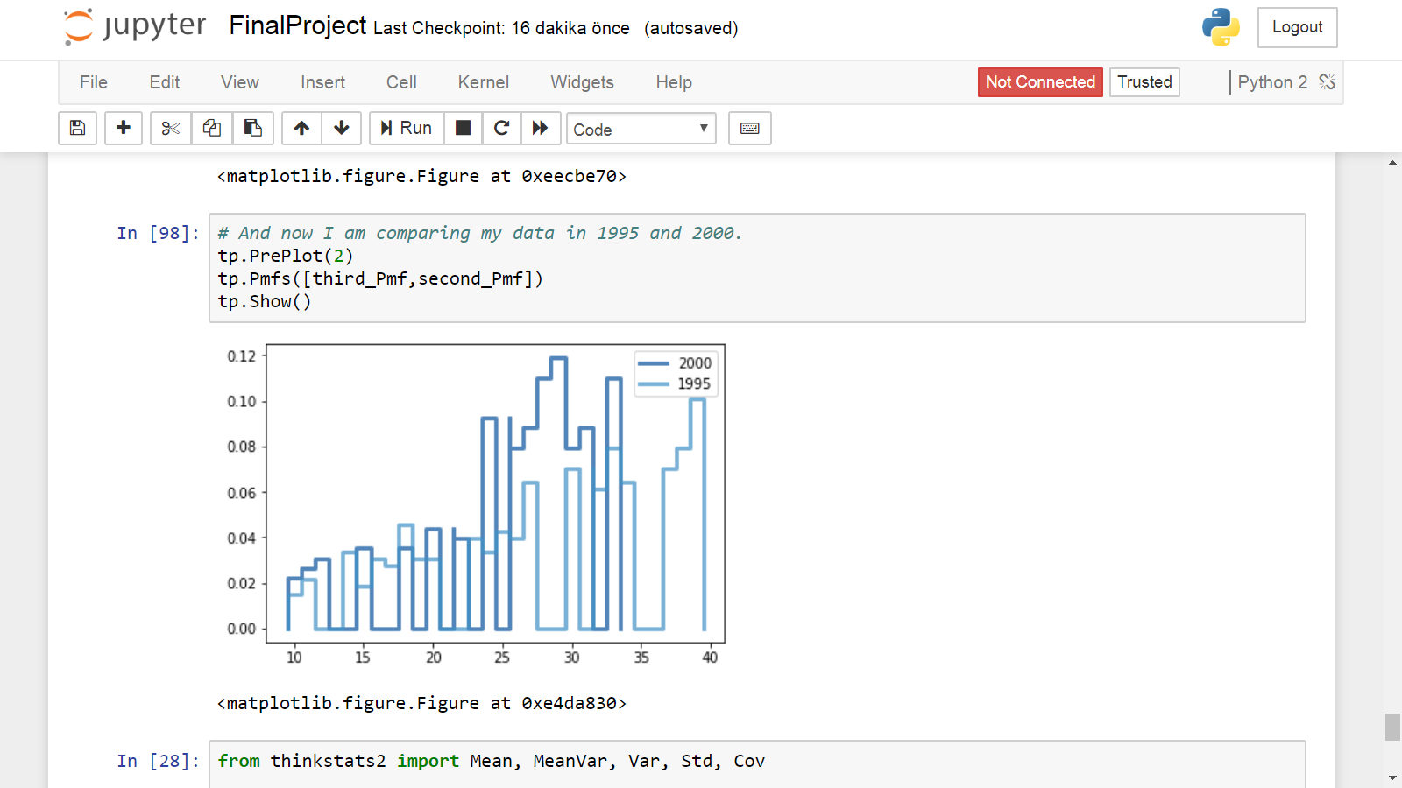

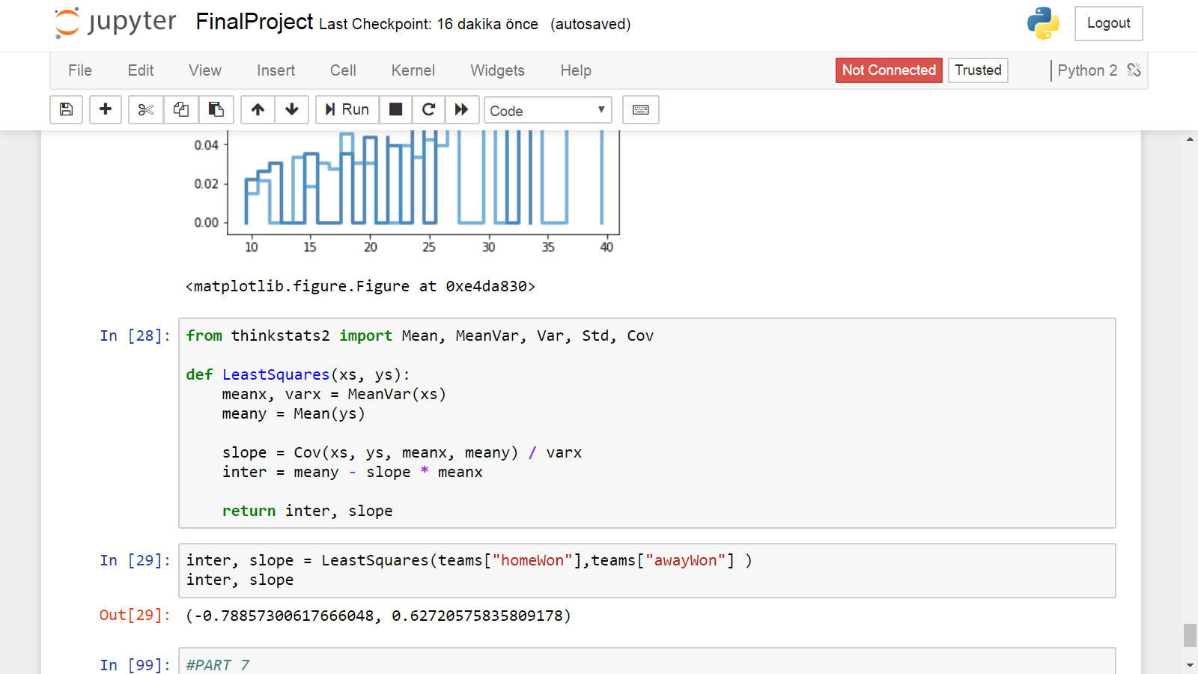

PART 7

So finally i can say that wonn is not eqauls to happines because for example in 2000 some teams which home won more away won the less.

So, Teams’ home won and away won also can different these are not totally related.